Stay Safe Policy

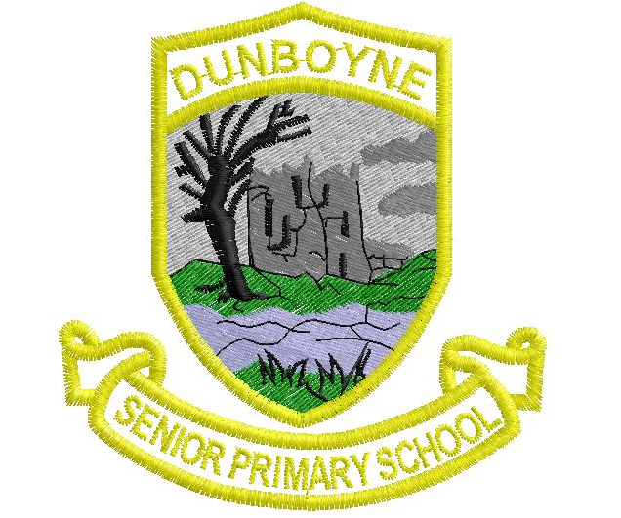

Dunboyne Senior Primary School

Main Street, Principal: An tUas Liam Ó Laighin
Dunboyne, Deputy Principal: Ms. Linda Manning
Co. Meath.
Tel/Fax: 8252803

Introduction
The staff of Dunboyne Senior Primary School formulated this school policy on Stay Safe in consultation with our Board of Management and our Parents’ Association. This policy was developed in line with current recommendations and guidelines relating to child abuse prevention and child protection guidelines.
The Stay Safe programme is a personal safety skills programme for primary schools. The aim of the programme is to reduce vulnerability to child abuse and bullying through the provision of personal safety education for children and training for teachers, school management boards and parents. It is developmentally structured to enable primary school teachers to deliver an abuse prevention education that addresses personal safety issues such as physical, emotional and sexual abuse as well as bullying and stranger danger.

Relationship to Ethos
Dunboyne Senior Primary School is a Catholic school under the patronage of the Bishop of Meath and therefore all policies developed are implemented in ways which are in keeping with the ethos of the school. Consequently this ethos is a guiding principle in the formulation and implementation of this Stay Safe policy. Our ethos also acknowledges the cultural and religious values of all the pupils attending the school. The school recognises that the parents are the primary educators of their children and we support and complement them in that role. Our ethos recognises the value and dignity of each pupil and all those working in the school community, and aims to promote the full and harmonious development of all aspects of the person.
Rationale
Child abuse has no boundaries. It occurs at every socio-economic level, crosses ethnic and cultural lines, and is found within all religions and at all levels of education.
The role of schools in prevention education is increasingly being recognised as imperative to the reduction of vulnerabilities of children to abuse.
“Child abuse is a leading cause of emotional, behavioral, and health problems across the lifespan. It is also preventable. School-based abuse prevention programs for early childhood and elementary school children have been found to be effective in increasing student knowledge and protective behaviors.” (Brassard and Fiorvanti, 2015)
As well as reducing children’s vulnerability to abuse, the Stay Safe programme aims to increase well-being and resilience by giving children knowledge, skills and strategies in an age-appropriate manner, using developmentally structured lessons and resources to empower them.
Research on the disclosure patterns of children showed that following their participation in the Stay Safe programme children were more likely to have purposively reported the abuse, were more likely to tell their teachers, and their reports were more likely to be substantiated (MacIntyre & Carr, 1999b).
The Stay Safe programme is part of the Social, Personal and Health Education curriculum which all primary schools are required to implement. The Stay Safe programme has been revised and updated and from 2018-2019 school year onwards, will be implemented in the school.

Content
Stay Safe is taught as part of the Social Personal and Health Education (SPHE) curriculum and as per best practice recommendations it will be taught on a rolling two-year cycle in the second term of the year (Third and Fifth Classes). In alternate years the Relationships and Sexuality Education (RSE) programme will be taught.
The lessons cover the following five topics:
- Feeling Safe and Unsafe
- Friendship and Bullying
- Touches
- Secrets and Telling
- Strangers
Pupils participating in the Stay Safe programme will learn:
  - About Feelings: To recognise the importance of feelings; how to express them appropriately and in particular to recognise unsafe feelings
  - About Friendship: Making and keeping friends and the value of friendship
  - About Bullying: What bullying is; strategies for dealing with bullying behaviour, and that it is never acceptable to bully others
  - The importance of building confidence and self esteem
  - How to identify and deal with inappropriate or unsafe touch
  - That it is ok to say ‘no’ to an adult in a situation where they feel unsafe, threatened or frightened
  - To identify trusted adults whom they should tell if they are feeling frightened, threatened, worried or unsafe in any way
  - To understand how someone might bribe, trick or threaten them to keep a secret
  - It is never their fault if they are victimised or abused
  - That they should never go anywhere with or take anything from a stranger
  - Appropriate language for telling
  - The Stay Safe rules: Say No, Get Away and Tell Never keep secrets about touch
  - Never go anywhere with or take anything from a stranger

Policies which support Stay Safe:
Child Safeguarding Statement
Code of Behaviour
Anti-Bullying
Anti-Cyber Bullying
Enrolment
Healthy Eating
Acceptable Use of the Internet
Intimate Care
Health and Safety
RSE
Special Educational Needs
SPHE
PE

Organisational Matters:
- Parents will be informed in advance of the commencement of the Stay Safe programme.
- If children are withdrawn from the lessons pertaining to the sensitive elements of the Stay Safe programme, they must give notice in writing to the school that they are withdrawing their child. The child will be accommodated in another teacher’s classroom in the school.
- Parents have a responsibility to become involved, to inform themselves of the programme content and to prepare children for the information they will acquire around the sensitive areas and discuss areas covered in Stay Safe/SPHE. Parents are invited/welcome to view the curriculum and may speak to the class teacher if they have any concerns.
- In the class situation children will be encouraged to recognise that certain information is for them only and it would be inappropriate to discuss this with younger siblings/children for example.
- With regard to matters of a confidential nature, the school cannot take any responsibility for what is discussed in the yard or classroom.
- Special consideration will be taken to ensure that the needs of children with special educational needs are met. Taking into account the pupil’s social and emotional development, instruction will be based on individual needs where possible. Parents will be consulted around sensitive issues.

Child Protection

This policy is cognisant of all aspects of our current Child Protection Statement. The school follows the Department of Education and Skills child protection guidelines and has a Child Safeguarding Statement with the Principal as Designated Liaison Person (DLP) and the Deputy Principal as the Deputy DLP. Where a child protection concern is raised, the procedures outlined in the schools Child Safeguarding Statement will be followed.

Resources:
The Stay Safe Programme: Personal Safety Skills for 3rd and 4th Class
The Stay Safe Programme: Personal Safety Skills for 5th and 6th Class
www.staysafe.ie

Provision of Ongoing Support
- Opportunities provided by our Education Centre will be brought to the attention of staff members. Teachers will be encouraged to attend CPD in RSE.
- Application for in-school support from PDST sought when necessary.
- Staff meetings utilised as a platform for discussion and development of RSE materials.

Review
This will be reviewed at regular intervals or in response to new Department Circulars/Directives.

Ratification

This plan was ratified by:

_____________________________________________ on _____________________
Chairperson, Board of Management

